Accuracy of digital occlusal records versus conventional mechanical methods

M. Attia
Lecturer of Fixed Prosthodontics, Faculty of Dentistry Modern Sciences and Arts University
Email: Dr.mahmoudattia.ma@gmail.com

M. Wahsh
Professor of Fixed Prosthodontics, Faculty of Dentistry, Ain Shams University
Email: marwa.wahsh@dent.asu.edu.eg

N Z Fahmy
Professor of Fixed Prosthodontics, Faculty of Dentistry Modern Sciences and Arts University
Email: nadiafahmyz@hotmail.com

A Aboelfadl
Associate Professor of Fixed Prosthodontics, Faculty of Dentistry,Ain Shams University
Email: a.aboelfadl@gmail.com

M Zohdy
Associate Professor of Fixed Prosthodontics, Faculty of Dentistry, Ain Shams University
Email: dr.magedzohdy@gmail.com

Abstract---Background: The stomatognathic system includes the relationship between teeth, masticatory muscles and temporomandibular joints. Achieving Occlusal stability via occlusal equilibration is mandatory for healthy stomatognathic system. Aim: Assessment of accuracy of two digital occlusal records and mechanical records using semi adjustable articulator through ob jective and subjective methods)Methodology: 7 patients were evaluated with total of 21 PMMA FDP to restore missing 1st permanent molar using different occlusal recording methods. Group (C) conventional mechanical articulator, Group (M) mathematically Simulated Articulator & Group (P) patient-specific motion. Occlusense and articulating paper was used to analyze occlusal accuracy and patient satisfaction was done via questionnaire. Results: There was significant in postoperative records in all groups as P < 0.05 by using Paired t-test, while there was insignificant difference between all groups as P > 0.05 by using One Way ANOVA test, in patients’ satisfaction, comparison between different groups performed by using Chi-square test which demonstrated that Group (P) revealed the best results. Moreover, correlation between occlusal forces analysis & patient satisfaction revealed insignificant correlation (P<0.05) Conclusion: The three methods of occlusal recording techniques showed comparable results

Keywords---Mechanical articulator, virtual articulator, digital articulator, mathematically simulated articulator, occlusal analysis, occlusal equilibration.

Introduction

One of the goals of prosthodontic treatment is maintenance and/or reestablishment of a good dental occlusion when the treatment is completed. Therefore, restorative treatment should be aimed at the achievement of smooth unhindered mandibular movements during function. The outcome should not result in an occlusal interference, nor should it lead to the generation of excessive force on the teeth, the periodontal apparatus or the temporomandibular joints (TMJs). All members of the masticatory system should work in harmony and accommodate the changes in occlusal morphology of the finished restoration well. (15)

The modern concept of occlusion demonstrated that temporomandibular joint (TMJ) should be in its most orthopedically stable position as determined by centric relation (CR), the masticatory muscles should be in balance, the teeth should intercuspation simultaneously with equal intensity in CR, and the anterior guidance should be in balance with the envelope of function. ^{[1]} To minimize occlusal modifications on the new restoration, it is crucial to transmit the proper maxillomandibular relation. ^{[2]}

Nowadays, the wax-up process is used in about 90% of technical dental work to create the cast framework before the design work is completed with the hand ceramic stage. ^{[3]} In this setting, mechanical articulators are essential. Technicians use them to monitor jaw movement and the connection between the upper and lower jaws while also employing them as holders for fabrication. ^{[4]}

Unfortunately, the movements reproduced by the mechanical articulator follow the margins of the structures that conform to the mechanical joint, which remain constant over time, and which cannot simulate masticatory movements, which depend on the muscle patterns and resilience of the soft tissues and joint disc. Mechanical articulators and facebow are used to simulate mandibular movements to have an accurate replica of the patient's occlusion relationship. ^{[5,6]}

The CAD/CAM technologies become a new era in dentistry, accordingly mechanical articulators are less frequently used, and virtual articulators take over the place of traditional articulators. For the examination of static and dynamic occlusion, the virtual articulator has been developed. To replace mechanical articulators and avoid their flaws and limits, this gadget blends virtual reality applications into dental treatment. ^{[7]}

This study was conducted to assess of accuracy of two digital occlusal records (mathematically simulated virtual articulator and dynamic jaw tracking via patient specific motion) and mechanical records using semi adjustable articulator taken from patients receiving three-unit PMMA FDP.The null hypothesis was that the occlusal records of patient specific motion would have similar accuracy compared to mathematically simulated articulator and conventional mechanical articulator.

Materials and Methods:

Sample size:

This randomized clinical trial was performed in the Fixed Prosthodontic Department, Faculty of Dentistry, Ain Shams University. In this study, 21 FDP was used (7 patients in each group) by using PS Power software, sample size calculation depended on related study ^{[8]} as a reference as the true mean difference between both groups was 11.9, and the standard deviation was 9.3. The Type I error probability associated with this test of this null hypothesis was 0.05 with 80% probability (power).

Ethical Approval:

All patients were told of the practical stages of this study and provided with a written approved agreement before the study was conducted in accordance with the Declaration of Helsinki, which was adopted in 1975. The Ethical Committee Permission (706)- Ain Sham University provided the ethical approval.

Study design:

In this, in vivo study, a total of seven systemically free patients were selected with missing mandibular 1st permanent molar these patients’ express concerns regarding implant line of treatment and desire FDP to evaluate occlusal accuracy of 3 provisional FDP done by 3 different occlusal recording techniques.

- Group (C) conventional mechanical articulator.

- Group (M) mathematically Simulated Virtual Articulator.

- Group (P) patient-specific motion (mandibular motion tracking device).

Blinding

Trible blinding was done in this study, where the trial participants, outcome assessors (prosthodontic colleagues) and statistical analyst were blinded throughout the whole procedure, as the operator (the researcher) was responsible for all experimental procedures.

Eligibility criteria:

All selected patients were systemically free, age ranging from 23 to 45 years, missing mandibular 1st permanent molar, asymptomatic adapted occlusion, angle class I occlusion, favorable C/R ratio, and axial inclination less than 25% of abutment teeth. On the other hand, patients with parafunctional habits, attrition and erosion, maxillofacial surgeries, temporomandibular disorder, severe crowding, centric and eccentric interferences, and current orthodontic treatment were excluded.

Participant timeline:

The patients were treated in visits including the following steps:

Visit 1 (Preoperative phase): Including the collection of patients' medical and dental history, clinical records, periapical radiographs, assessment of mouth opening, and TMJ via load testing. Face-to-face adherence reminder session, signing consents after explaining all the procedures as well as intra-oral photograph was taken according to AACD standards. As shown in figure (1)

Visit 2 (Occlusal analysis phase): control phase (scaling root planning and restoring any defective restorations if found) The patient’s adapted occlusion was checked using the Occlusense.to check for any premature contacts on both centric via percentage of bite force analysis at MIP and eccentric movements via lateral mandibular movement analysis

Patient maximum intercuspation was checked again by introducing the sensor into the patient’s mouth. The bite force were evaluated on iPad Application as shown in figure (2). The records were taken 5 times to ensure the maximum repetition of the bite force and to exclude any false reading before any prosthetic construction. The saved data was used again after finishing the final 3 FDP to compare the patient FDP samples with the saved adapted patient recorded data.

Full mouth scanning was done before any dental procedure using Trios 3 IOS to generate a Stereolithography STL to prepare indirect provisional FDP.

The provisional PMMA was designed Dental Designer software, to produce the provisionals with identical shape, morphology, and occlusal contact of the intact abutment tooth with pontic out of occlusion to avoid any occlusal changes or prematurity that could alter the patient’s adapted occlusion as shown in figure (3).

Visit 3 (Abutment preparation phase): Teeth preparation was done followed by: impression making, bite registration, facebow recording, full mouth scanning, jaw records, as shown in figure (4 A & B). Temporization using readymade relined FDP PMMA subtractive shells

Visit 4:(Assessment stage) The following week temporary CAD FDP fabricated using 3 different occlusal recording methods was ready for assessment. Analysis of occlusion of the 3 FDP using Occlusense, articulating paper and patient analysis questionnaire was performed.

Laboratory procedures were divided as follows:

I. Group (C) Conventional technique:

Maxillary and mandibular dental casts were mounted on an SAA articulator as shown in figure (5) followed by cast scanning using E2 lab scanner starting with the maxillary cast followed by the mandibular cast then bite scanning was done for the right and left sides at MIP. The point cloud scan was then transformed into STL files and data were transmitted to CAD designer software to design 1st FDP the intensity of occlusal contact points was checked before milling of provisional FDP.

II. Group (M) Mathematically simulated technique:

The previously mounted articulator was adjusted on each patient-specific Bennet and Condylar angle which was recorded from the patient’s mouth using bite registration material. Articulator scanning was done and fixed in position using an articulator holder. The same FDP design was selected, and the centric contacts were set as the previously mentioned group (C). The same virtual articulator (Bioart Elite A7 plus) was selected and used to transfer the analog articulator customized values of each patient (Bennet and Condylar angles) to the virtual articulator settings for each patient to mathematically simulate the patient’s mandibular movements, as shown in figure (6,7).

The PLY facial scans for each patient were used to align maxillary cast STL file scans with facial scans via superimposition of both PLY file and intra-oral STL scan files. After aligning face scans with jaw scans as shown in figure (8).

The CAD designing was resumed to adjust eccentric contacts virtually by pressing the icon (adapt) on the CAD software in which the virtual articulator simulated each patient mandibular movements and automatically adjusted the eccentric contacts,

III. Group (P) patient-specific motion technique:

Patient preparation scans, as well as Static and dynamic mandibular movements, were transferred to CAD software 3 Shape dental system via 3OXZ which is 3Shape Order Exchange Format Data. CAD designing was done on both groups (C) and (M) for each patient. After the final design of centric contact, the eccentric contact was checked by pressing the icon of PSM in CAD software to generate patient dynamic jaw movements then adapting the virtual design to adjust both centric and eccentric occlusal contact. The final design of provisional PMMA FDP was sent to the 5-axis milling machine, as presented in figure (9).

Assessment of occlusal accuracy

A week after the preparation, the 3 FDPs were coded and put in opaque sealed envelopes by an assisting dental colleague, who kept track of the code throughout the whole study

The 1st coded FDP was cemented using ITENA long term temporary cement the FDP was stabilized in position using operator finger tap 1st and asking the patient to bite on cotton roll until setting of temporary cement.

60 micron Occlusense sensor was introduced inside each patient’s mouth in order to evaluate the percentage of bite force

Articulating paper was used starting with 80 microns descending to 8 micron articulating foil.

Two 80 micron articulating paper were introduced into a patient mouth via articulator holder on both sides, then the patient was asked to bit on MIP. The operator tried to pull the paper from opposite side during patient biting it was observed the 80 micron papers were balanced on both sides for every tested groups. The pervious test was repeated for 40, 24, 12 and 8 microns. It was found that some groups had premature contacts in the provisional FDP of 40 microns other of 24 and 8 microns.

After finishing evaluation of 1st design, patient was asked to put cotton roll between the upper and lower anteriors for 15 minutes for muscle deprogramming before testing 2nd and 3rd FDP.

All data were collected and sent to statistician with coded envelopes for statistical analysis.

The best design of provisional FDP with least interferences was converted into monolithic zirconia FDP as shown in figure (10)

Patients` satisfaction evaluation:

Patient satisfaction regarding provisional FDP was assessed in terms of: (appearance, cleanability, chewing ability, speech, and overall satisfaction of fixed prosthodontic), The satisfaction of the patient was measured on a questionnaire with a rating score of satisfied, neutral, or unsatisfied

Statistical analysis and data management:

Data were collected, tabulated, and statistically analyzed using Microsoft Excel ® 2016, Statistical Package for Social Science (SPSS)® Ver. 24. and Minitab ® statistical software Ver. 16.

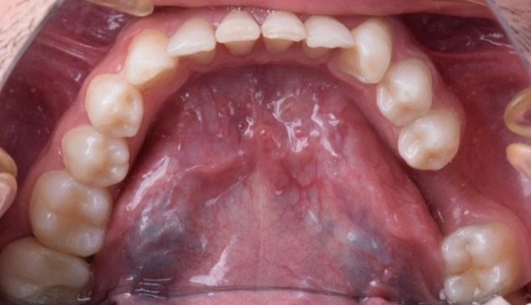

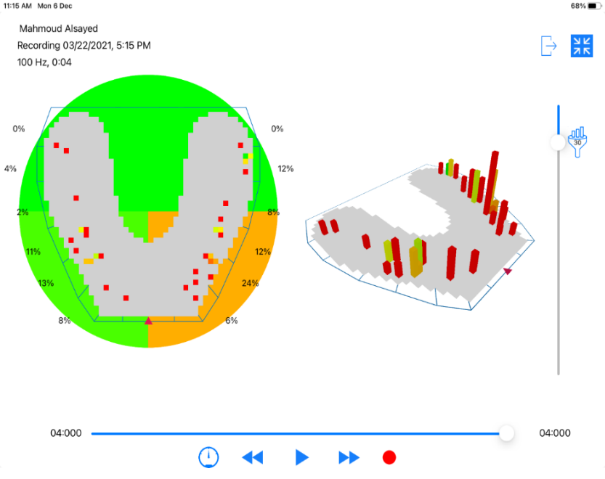
Figure 1: clinical preoperative intraoral photograph showing Mandibular Occlusal view

Figure 2: Occlusal bite analysis showing patient MIP in which the color map described cusp steepness while the column height indicated bite force intensity.

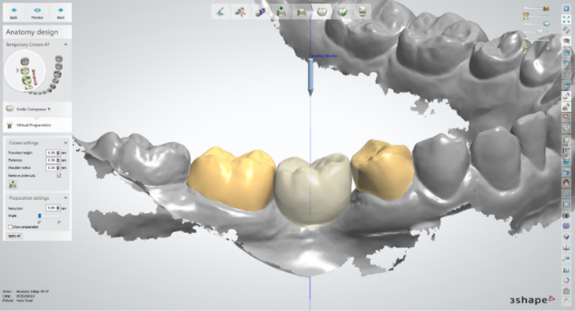

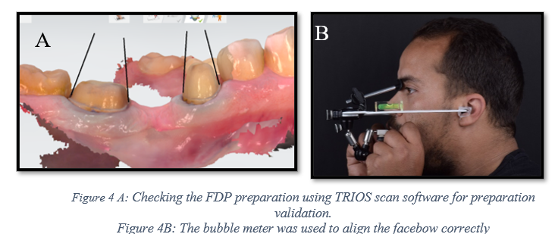
Figure 3: Subtractive reduction of the abutments to receive the temporary FDP.

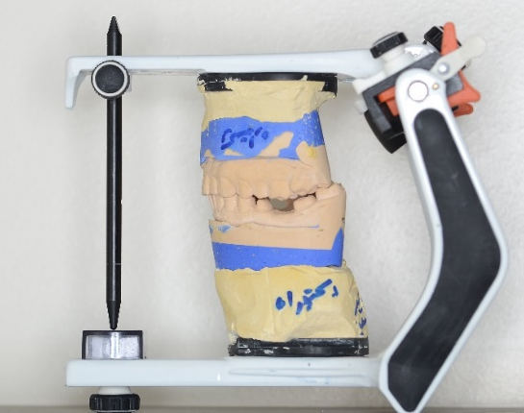

B

Figure 5: SAA after mounting of the maxillary and mandibular cast.
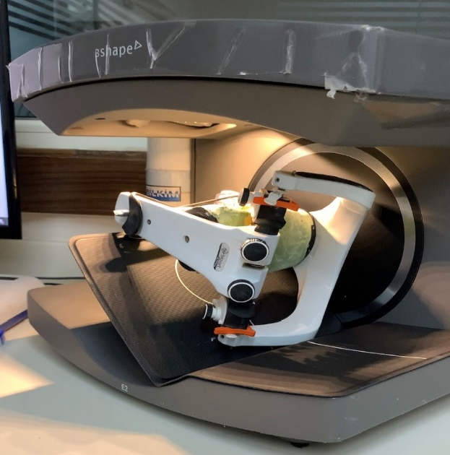

Figure 6: Showing the 3Shape E2 scanner with the articulator fixed in position by the articulator holder.

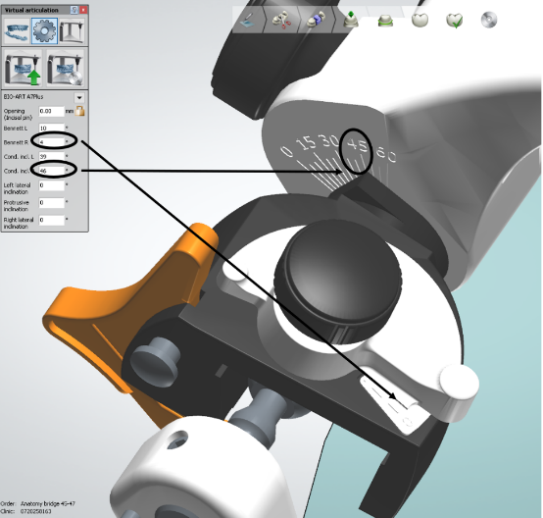

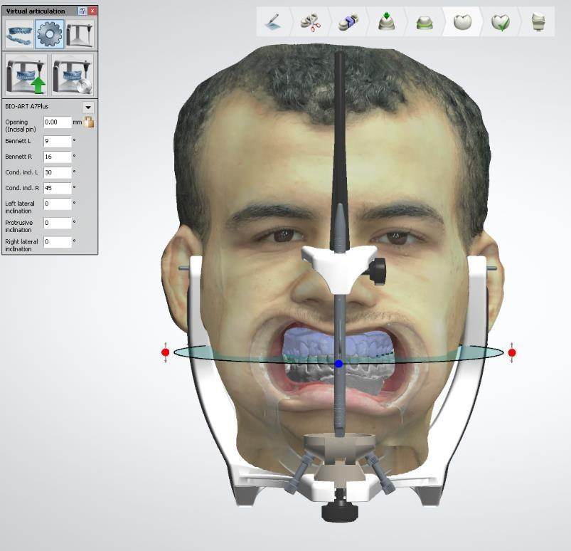
Figure 7: Setting virtual articulator on patient customized (Bennet and condylar) angles.

Figure 8: Aligning the face scan with the upper model on the virtual articulato
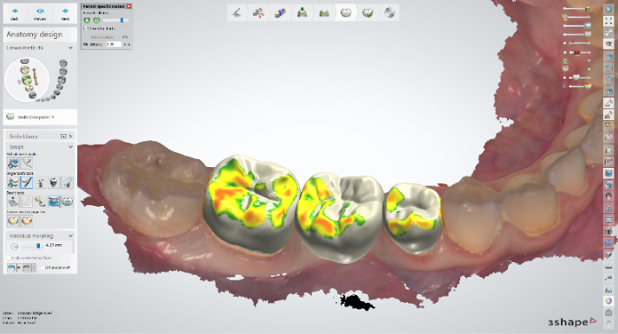
Figure 9: Occlusal contacts after adjusting using patient-specific motion

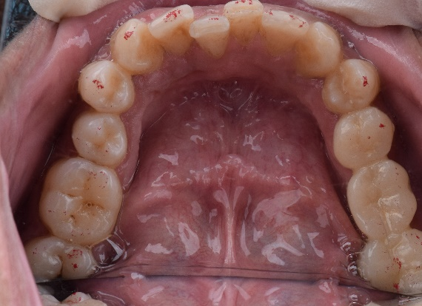

Figure 1: The provisional PMMA FDP with the lest occlusal interferences

Results

Exploration of the given data (quantitative data of occlusal accuracy) was performed using Shapiro-Wilk test and Kolmogorov-Smirnov test for normality and revealed insignificant difference as P-value > 0.05 which indicated that data originated from normal distribution (parametric data) resembling normal bell curve.

- Assessment of occlusal accuracy:

Comparison between preoperative and post operative records

Comparison between preoperative and post operative records was performed by using Paired t-test which revealed significant difference in all groups as P <0.05 (significant decrease in opposite side and significant increase in missing side), as presented in table (1) and figure (11)

Comparison between opposite and missing sides

Comparison between opposite and missing sides was performed by using Independent t-test which revealed significant difference in preoperative records of all groups as P<0.05 (opposite side significantly higher than missing side), while in post operative records there was insignificant difference between them in group (C) and group (P) but in group (M) missing side was significantly higher than opposing side, as presented in table (1) and figure (11)

Comparison between different groups

Comparison between different groups revealed insignificant difference between them as P>0.05 regarding opposite side and missing side as P > 0.05, as presented in table (2) and figure (11).

- Patients` satisfaction evaluation:

Comparison between different answers within each group:

In group C, satisfied was significantly the highest in Q1, Q2 & Q4 at P < 0.05, while there was an insignificant difference between answers in Q3 & Q5 at P > 0.05. In group M, satisfied was significantly the highest in Q1, Q2 & Q4, while unsatisfied was significantly the highest in Q3 &Q5 at P < 0.05. In group P, satisfaction was significantly the highest in all questions at P < 0.05, as presented in table (3) and figure (12).

Comparison between different groups:

Comparisons between different groups revealed insignificant differences between them in Q 1, 2 & Q 4 as P > 0.05. In Q 3 there was a significant difference between groups as P < 0.05, as satisfied revealed the highest answer in group P, while unsatisfied revealed the highest answer in group M. In Q5, satisfied answer was significantly the highest in group P, as presented in table (3) and figure (13).
- Correlation between patient satisfaction and occlusal forces analysis:

Correlation between occlusal forces analysis & patient satisfaction among missing side & opposite side was performed in all questions and revealed insignificant correlation (P<0.05) ranged from weak to moderate.

Table (1)
Comparison between preoperative and postoperative readings and comparison between opposite side and missing side in all groups:

 | Side | Preoperative records of missing teeth |  | Postoperative records of prosthetic teeth |  | P value
 | Side | M | SD | M | SD | P value
Group C | Opposite side | 59.42 | 4.8 | 51.2 | 3.8 | 0.04*
Group C | Missing side | 40.57 | 5.2 | 49.7 | 3.7 | 0.01*
Group C | P value | 0.0001* |  | 0.47
Group M | Opposite side | 59.42 | 4.8 | 46.8 | 6.71 | 0.001*
Group M | Missing side | 40.57 | 5.2 | 54.6 | 7.32 | 0.001*
Group M | P value | 0.0001* |  | 0.05*
Group P | Opposite side | 59.42 | 4.8 | 51.1 | 6.83 | 0.04*
Group P | Missing side | 40.57 | 5.2 | 48.28 | 6.33 | 0.02*
Group P | P value | 0.0001* |  | 0.28

M: mean SD: standard deviation *Significant difference

Table (2)
Comparison between all groups regarding opposite and missing sides:

Post operative records | Opposite side |  | Missing side
Post operative records | M | SD | M | SD
Group C | 51.2 | 3.8 | 49.7 | 3.7
Group M | 46.8 | 6.71 | 54.6 | 7.32
Group P | 51.1 | 6.83 | 48.28 | 6.33
P value | 0.31 |  | 0.14

M: mean SD: standard deviation

Table (3)
Frequency & percentages of different answers of patient satisfaction questionnaire in all groups:

 | Group | Unsatisfied |  | Neutral |  | Satisfied |  | P value
 | Group | N | % | N | % | N | % | P value
Q1 | Group C | 0 | 0.00% | 0 | 0.00% | 7 | 100.00% | <0.0001*
Q1 | Group M | 0 | 0.00% | 0 | 0.00% | 7 | 100.00% | <0.0001*
Q1 | Group P | 0 | 0.00% | 0 | 0.00% | 7 | 100.00% | <0.0001*
Q1 | P value | ------------ |  | ------------ |  | 1
Q2 | Group C | 0 | 0.00% | 0 | 0.00% | 7 | 100.00% | <0.0001*
Q2 | Group M | 0 | 0.00% | 0 | 0.00% | 7 | 100.00% | <0.0001*
Q2 | Group P | 0 | 0.00% | 0 | 0.00% | 7 | 100.00% | <0.0001*
Q2 | P value | ------------ |  | ------------ |  | 1
Q3 | Group C | 2 | 28.60% | 4 | 57.10% | 1 | 14.30% | 0.11
Q3 | Group M | 4 | 57.10% | 3 | 42.90% | 0 | 0.00% | 0.02*
Q3 | Group P | 0 | 0.00% | 2 | 28.60% | 5 | 71.40% | 0.007*
Q3 | P value | 0.02* |  | 0.29 |  | 0.007*
Q4 | Group C | 0 | 0.00% | 0 | 0.00% | 7 | 100.00% | <0.0001*
Q4 | Group M | 0 | 0.00% | 0 | 0.00% | 7 | 100.00% | <0.0001*
Q4 | Group P | 0 | 0.00% | 0 | 0.00% | 7 | 100.00% | <0.0001*
Q4 | P value | ------------ |  | ------------ |  | 1
Q5 | Group C | 2 | 28.60% | 4 | 57.10% | 1 | 14.30% | 0.11
Q5 | Group M | 4 | 57.10% | 3 | 42.90% | 0 | 0.00% | 0.02*
Q5 | Group P | 0 | 0.00% | 3 | 42.90% | 4 | 57.10% | 0.02*
Q5 | P value | 0.29 |  | 0.58 |  | 0.02*

N: count %: percentage P: probability level which is significant at P ≤ 0.05

Group (C) conventional mechanical articulator. Group (M) mathematically Simulated Virtual Articulator.

Group (P) patient-specific motion (mandibular motion tracking device

Figure (11): Bar chart repesenting comarison between preoperative and postoperative records of opposite and missing sides of all groups.

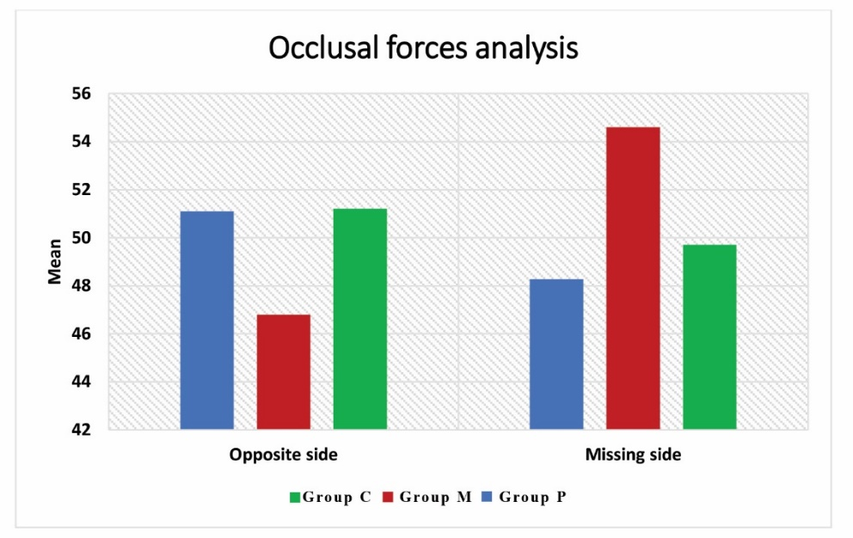

Figure (12): Bar chart representing comparison between all groups in both opposite and missing sides.

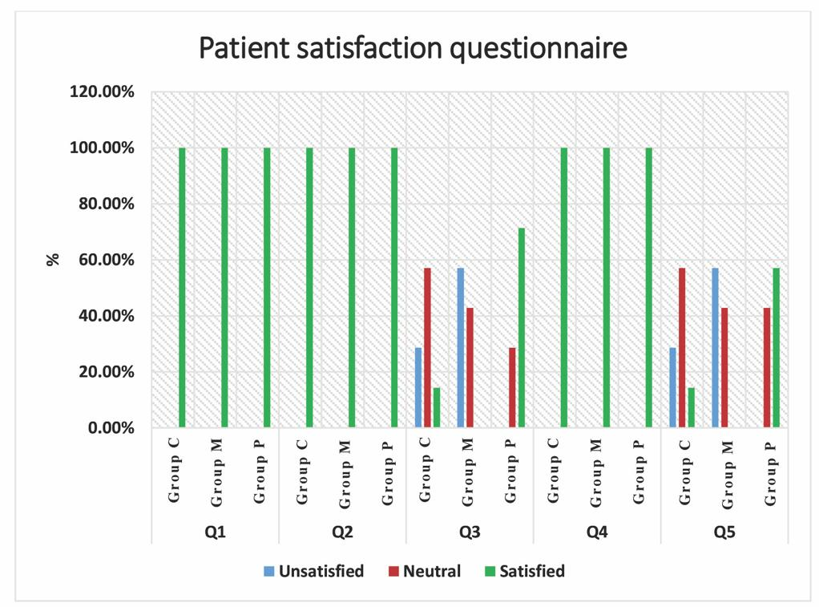

Figure (13): Bar chart representing patient satisfaction in all groups.

Discussion

The null hypothesis of the current study was accepted as there was no statistically significant differences between the three groups.

For group C, the preoperative records of the mean bite force of all patients on the missing side were (40.57) while on the opposite side was (59.43). Postoperatively the bite force was (51.2) on the missing side and (49.7) on the opposite side. By comparing the pre and post-operative records after receiving provisional FDP there was a statistically significant difference in which the bite force increased significantly in the missing area and decreased in the opposite area. It may seem that the bite force was more evenly distributed due to the new contacts generated from the provisional FDP. This change could be because the area of the missing tooth was less functioning before restoring the tooth with provisional FDP after the pontic become in contact with the total area of the missing tooth that had new contacts which might be the cause for more balancing occlusion as there was more contact distribution.
On the other hand, there was a statistically significant difference between the missed and opposite area before and after prosthetic restoration in which the preoperative opposite side recorded higher force than the missing side, while the postoperative opposite side was lower than the missing side. This finding may be due to the presence of slight prematurity in the FDP in which the bite force increased significantly at the restored side causing decreased force on the opposite side. This was confirmed when using articulating paper sizes 80, 40, and 24. 12 µ in addition to articulating foil with 8 µ.

The slight premature contacts generated via conventional technique could be due to using a mechanical semi-adjustable articulator as it mainly focuses on reproducing the maxilla-mandibular relationship rather than the mandibular dynamic functional movements which may generate new contact in the master model in the articulator. ^{[9]}

Another study by Ghezal et al. 2017, ^{[10]} the vertical displacement of the condyle generated by the inter occlusal recordings was larger than the lateral or the anteroposterior displacement, according to research on the impact of various inter occlusal records on condylar displacement.

For group M, there was a statistically significant difference in comparison between preoperative records of missing teeth & postoperative records of prosthetic teeth on both opposite and missing sides: (Preoperative records were significantly lower on the opposite side, while were significantly higher on the missing side). Also, a comparison between opposite & missing sides revealed a significant difference as P < 0.05 in both preoperative records of missing teeth and postoperative records of prosthetic teeth (in the preoperative opposite side was higher than the missing side, in the postoperative opposite side was lower than the missing side). The percent of change was (-21.2%) on the opposite side & (34.8 %) on the missing side.

It was found that the mathematically simulated technique had the highest bite force at the missing side in comparison with the (C) and (P) groups. It could be due to the premature contacts generated in the FDP from this technique which were higher than the other techniques. This finding was confirmed when the patient occlusal interferences were checked as previously mentioned with articulating papers it was found that 24 µ articulating paper was withdrawn on the sound opposite side which reveals that in this technique the premature contact in the FDP was higher than 24 microns and less than 40 µ. this finding was confirmed via patient satisfaction questionnaire.

This disagrees with the findings of Kordass et al. 2002. ^{[11]} and Gartner et al. 2003. ^{[12]} who stated that the virtual articulator with mathematically simulated mandibular movements was assumed to overcome the errors generated by mechanical articulators. It was found that the premature contact generated from this technique in the current study with customized values was slightly higher than the other two tested groups.

Another explanation that could alter the accuracy of the mathematically simulated technique is that the most crucial steps in the fabrication of a virtual patient include maxillary cast alignment (angle and position) to the facial scan, in the current study we used a smartphone application as an alternative to face bow and CBCT to align the maxillary cast into virtual articulator. This technique might affect the trueness and precision of the final transferred data. This finding was in agreement with Li et al. 2021 ^{[13]} when they investigated the trueness and precision of virtual facebow records using a smartphone face scanning when the face scanning was superimposed with CBCT of the same subject it was found that the deviation anticipated as around 1mm in the linear distance and 1 degree in angulation.

For group P, it was found that there was a statistically significant difference between preoperative records of missing teeth & postoperative records of prosthetic teeth revealed in both opposite and missing sides as P< 0.05. Also, a comparison between opposite & missing sides revealed a significant difference as P < 0.05 in both preoperative records of missing teeth and postoperative records of prosthetic teeth (in the preoperative opposite side was higher than the missing side, in the postoperative opposite side was lower than the missing side).

As mentioned in the conventional group this could be due to better force distribution after receiving FDP. However, in this technique, mandibular motion tracing via IOS was used without face bow transfer. It was found that the preoperative records of bite force at the missing side increased after receiving FDP but did not exceed the opposite side.

Patient-specific motion (PMS) technique overcomes the multiple steps of error of conventional procedure as impression dimensional change, face bow errors and transferring, and mounting of articulator errors. Another explanation may be that patient dynamic mandibular movement recorded via IOS (patient-specific motion) could reduce occlusal interference in eccentric movement by reproducing functional mandibular movements in CAD software. This finding was in agreement with Lee et al. (2020) ^{[14]} who compared occlusal design adjusted using PSM with conventional methods using a semi-adjustable articulator. It was concluded that there was a statistically reduced occlusal error in the group with adjustments using PSM on the out-of-tolerance area compared to the group design based on static occlusion. By comparing the restored side and opposite side postoperatively it was found that the restored area records a lower value than the opposite side. It could be due to minimal occlusal interferences generated by FDP in this technique.

Another possibility is that the occlusal area of the teeth, which is mostly governed by the number of functioning teeth, has a role in how food is broken down. ^{[15]} Similarly, maximal biting force reduction is connected to impaired dentitions, such as tooth loss and broken occlusal contacts, and serves as an essential marker for assessing the functional health of the chewing system. ^{[16]} The addition of a functional tooth unit (FTU), also known as two opposing teeth occluding one another, resulting in an increase in contact points and surface area and a redistribution of pressure. It may be anticipated that the improvement in chewing performance is accompanied by an increase in biting force and mastication units on the repaired side as there was a link between bite force and chewing ability. ^{[17, 18]}
When comparing the 3 tested groups there was no statistically significant difference within the groups with slight privilege for digital methods (patient-specific motion) which was a user-friendly technique with less time consumption for the dentist and the patient as well as more accepted by all patients followed by mechanical conventional methods which is the gold standard technique and the last was mathematically simulated technique as it takes more time in both clinic and lab works and needs more investigation.

Conclusions

Within the current study, some limitations existed as there was a limited sample size as it was 21 FDP for 7 patients. The same patient was used to record and assess the three recording methods. There is insufficient data about digital occlusion and it needs more research and investigations. A smartphone application was used for the alignment of facial scans to the STL files without taking CBCT or any three-point reference. No gender comparison in our study.

The three occlusal recording techniques used in the study produced results that were equivalent. Clinically acceptable occlusal interferences were evident in all of the tested groups and were supported quantitatively, subjectively, and by patient questionnaire. A dependable, efficient in terms of time, and patient-friendly strategy is patient-specific motion. For the quantitative evaluation of biting force distribution and occlusal interference detection, a digital occlusal analyzer can be used.

References

- The Glossary of Prosthodontic Terms: Ninth Edition. J Prosthet Dent. 2017 May;117(5S):e1-e105. doi: 10.1016/j.prosdent.2016.12.001. PMID: 28418832.
- Okeson JP. Management of temporomandibular disorders and occlusion-E-book. Elsevier Health Sciences; 2019 Feb 1.
- Ortorp A, Jemt T, Bäck T, Jälevik T. Comparisons of precision of fit between cast and CNC-milled titanium implant frameworks for the edentulous mandible. Int J Prosthodont. 2003 Mar-Apr;16(2):194-200. PMID: 12737254.
- Gugwad RS, Basavakumar M, Abhijeet K, Arvind M, Sudhindra M, Ramesh C. Virtual articulators in prosthodontics. International journal of dental clinics. 2011 Oct 1;3(4):39-42.
- Kordass B, Gärtner C, Söhnel A, Bisler A, Voss G, Bockholt U, Seipel S. The virtual articulator in dentistry: concept and development. Dent Clin North Am. 2002 Jul;46(3):493-506, vi. doi: 10.1016/s0011-8532(02)00006-x. PMID: 12222093.
- Bisler A, Bockholt U, Kordass B, Suchan M, Voss G. The virtual articulator. Int J Comput Dent. 2002 Apr-Jul;5(2-3):101-6. English, German. PMID: 12680040.
- Sim JY, Jang Y, Kim WC, Kim HY, Lee DH, Kim JH. Comparing the accuracy (trueness and precision) of models of fixed dental prostheses fabricated by digital and conventional workflows. J Prosthodont Res. 2019 Jan;63(1):25-30. doi: 10.1016/j.jpor.2018.02.002. Epub 2018 Mar 31. PMID: 29615324.
- Afrashtehfar KI, Qadeer S. Computerized occlusal analysis as an alternative occlusal indicator. Cranio. 2016 Jan;34(1):52-7. doi: 10.1179/2151090314Y.0000000024. Epub 2014 Oct 16. PMID: 25323220.
- Koh H, Robinson PG. Occlusal adjustment for treating and preventing temporomandibular joint disorders. J Oral Rehabil. 2004 Apr;31(4):287-92. doi: 10.1046/j.1365-2842.2003.01257.x. PMID: 15089931.
- Goska JR, Christensen LV. Comparison of cast positions by using four face-bows. J Prosthet Dent. 1988 Jan;59(1):42-4. doi: 10.1016/0022-3913(88)90105-9. PMID: 3422301.
- Kordass B, Gärtner C, Söhnel A, Bisler A, Voss G, Bockholt U, Seipel S. The virtual articulator in dentistry: concept and development. Dent Clin North Am. 2002 Jul;46(3):493-506, vi. doi: 10.1016/s0011-8532(02)00006-x. PMID: 12222093.
- Gärtner C, Kordass B. The virtual articulator: development and evaluation. Int J Comput Dent. 2003 Jan;6(1):11-24. English, German. PMID: 12838585.
- Suryasa, I. W., Rodríguez-Gámez, M., & Koldoris, T. (2021). Health and treatment of diabetes mellitus. International Journal of Health Sciences, 5(1), i-v. https://doi.org/10.53730/ijhs.v5n1.2864
- Li J, Chen Z, Decker AM, Wang HL, Joda T, Mendonca G, Lepidi L. Trueness and Precision of Economical Smartphone-Based Virtual Facebow Records. J Prosthodont. 2022 Jan;31(1):22-29. doi: 10.1111/jopr.13366. Epub 2021 May 4. PMID: 33876857; PMCID: PMC8526632.
- Lee YC, Lee C, Shim JS, Park JM, Shin Y, Kim JE, Lee KW. Comparison between occlusal errors of single posterior crowns adjusted using patient specific motion or conventional methods. Applied Sciences. 2020 Dec 21;10(24):9140.
- van der Bilt A. Assessment of mastication with implications for oral rehabilitation: a review. J Oral Rehabil. 2011 Oct;38(10):754-80. doi: 10.1111/j.1365-2842.2010.02197.x. Epub 2011 Jan 17. PMID: 21241351.
- Gibbs CH, Anusavice KJ, Young HM, Jones JS, Esquivel-Upshaw JF. Maximum clenching force of patients with moderate loss of posterior tooth support: a pilot study. J Prosthet Dent. 2002 Nov;88(5):498-502. doi: 10.1067/mpr.2002.129062. PMID: 12473999.
- Hatch JP, Shinkai RS, Sakai S, Rugh JD, Paunovich ED. Determinants of masticatory performance in dentate adults. Arch Oral Biol. 2001 Jul;46(7):641-8. doi: 10.1016/s0003-9969(01)00023-1. PMID: 11369319.
- Julien KC, Buschang PH, Throckmorton GS, Dechow PC. Normal masticatory performance in young adults and children. Arch Oral Biol. 1996 Jan;41(1):69-75. doi: 10.1016/0003-9969(95)00098-4. PMID: 8833593.

